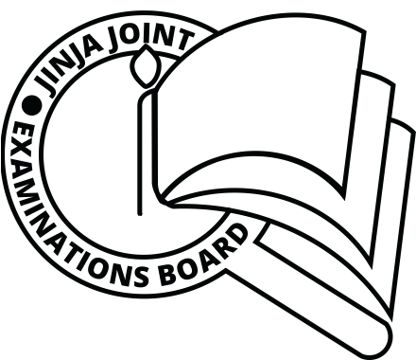**JINJAJOINTEXAMINATIONS BOARD**

**MOCK EXAMINATIONS FRENCH PAPER 1 P330/1 2022**

**MARKING GUIDE**

**BERÈME DE CORRECTION**

**SECTION A: LISTENING COMPREHENSION**

**1. C**

**2. C**

**3. A**

**4. B**

**5. A**

**6. A**

**7. B**

**8. D**

**9. B**

**10, C**

**Each correct answer is awarded 5 marks.**